Lab 5

Isaiah Hoffer

PART A:

LAB Q A1:

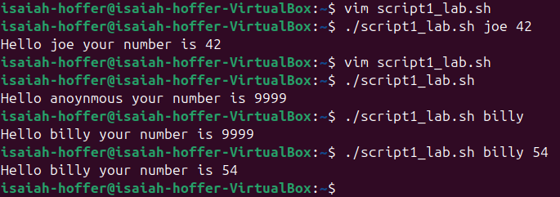

LAB Q A2:

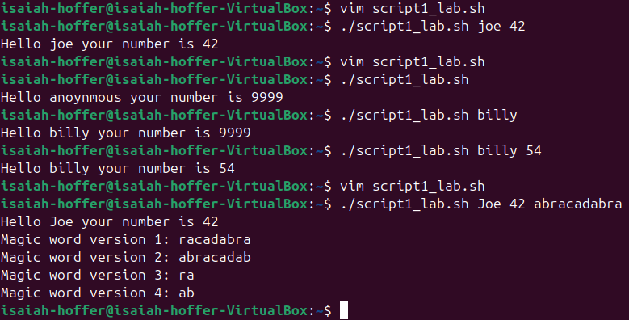

FINAL SCRIPT:

#! /bin/bash

echo "Hello ${1:-anonymous} your number is ${2:-9999}"

echo "Magic word version 1: ${3#a*b}" # Shortest match front

echo "Magic word version 2: ${3%r*a}" # Shortest match back

echo "Magic word version 3: ${3##a*b}" # Longest match front

echo "Magic word version 4: ${3%%r*a}" # Longest match back

exit

PART B:

LAB Q B:

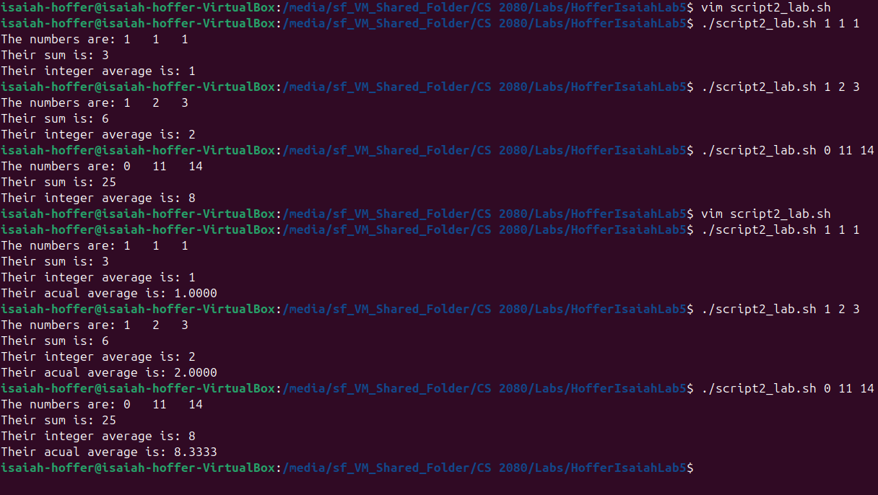

FINAL SCRIPT:

#! /bin/bash

# Variables

sum=$(($1+$2+$3)) # sum of arguments

average=$(($sum/$#)) # Integer average

average2=$(echo "scale = 4; $sum/$#" | bc) # Decimal average

# Displaying Results

echo "The numbers are: $1 $2 $3"

echo "Their sum is: $sum"

echo "Their integer average is: $average"

echo "Their actual average is: $average2"

exit

PART C:

LAB Q C1:

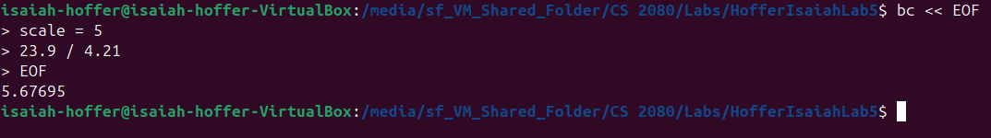

LAB Q C2:

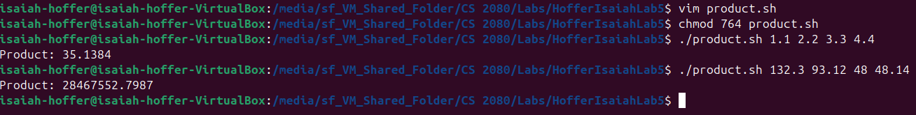

SCRIPT C2:

#!/bin/bash

product=$( bc << EOF

scale = 4

$1 * $2 * $3 * $4

EOF

)

echo “Product: $product”

exit

LAB Q C3:

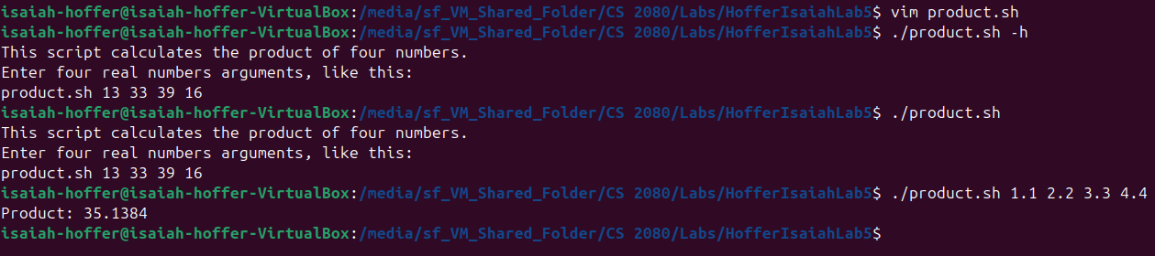

The lab said to copy the help text, but I didn’t make sense for the script we made, so I rewrote it, so it followed what the product script does, take the product of 4 numbers

FINAL SCRIPT:

#!/bin/bash

#if $1 is empty or $1 equals -h

If [[ -z $1 ]] || [[ $1 == “-h ]]; then

#Display Guide For Script

Cat << HELP

This script calculates the product of four numbers.

Enter four real numbers arguments, like this:

product.sh 13 33 39 16

HELP

#Calculating And Displaying Product

else

product=$( bc << EOF

scale = 4

$1 * $2 * $3 * $4

EOF

)

echo “Product: $product”

fi # Closing If Statement

exit